# Phase 3: Data Modeling & Relationships

## Standard & Custom Objects

Standard Objects used in ShopSmart CRM include: Accounts, Contacts, Products, Orders, and Cases.  
Custom Objects created include:  
- Order Item (Order_Item__c): Junction object to link Orders and Products.  
- Inventory (Inventory__c): Tracks stock levels for each product.

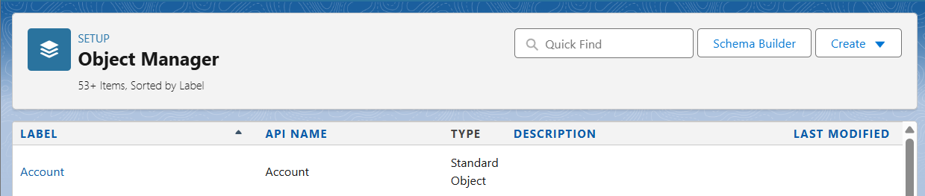









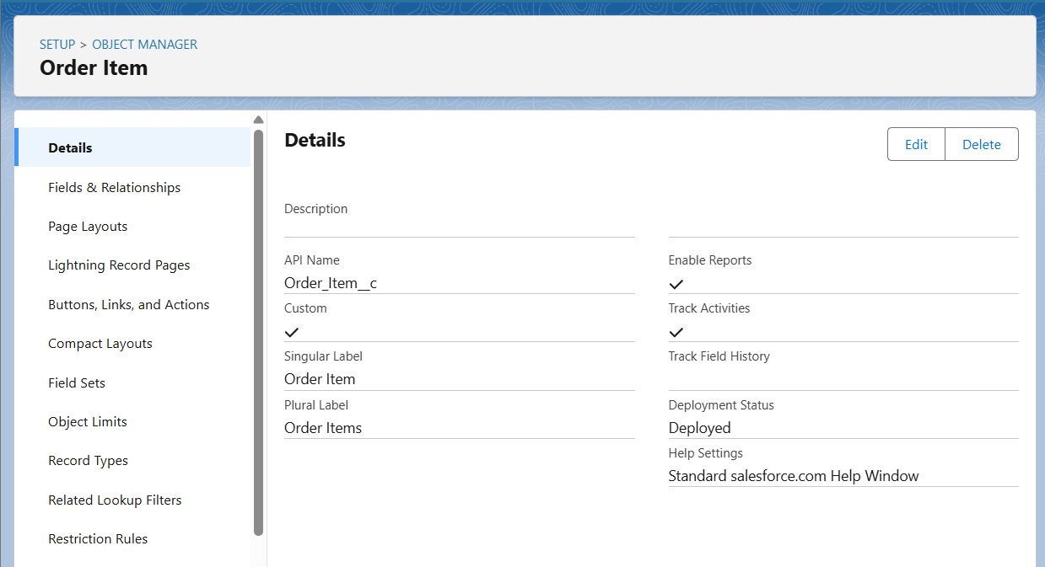

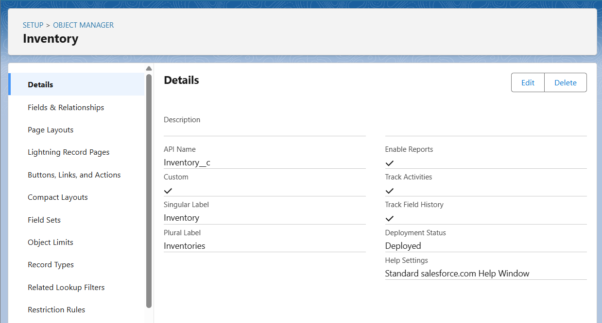

## Fields

Key custom fields were added to extend business functionality:  
  
Accounts:  
- Customer Tier (Picklist: Regular, Premium, VIP)  
- Preferred Payment Method (Picklist)

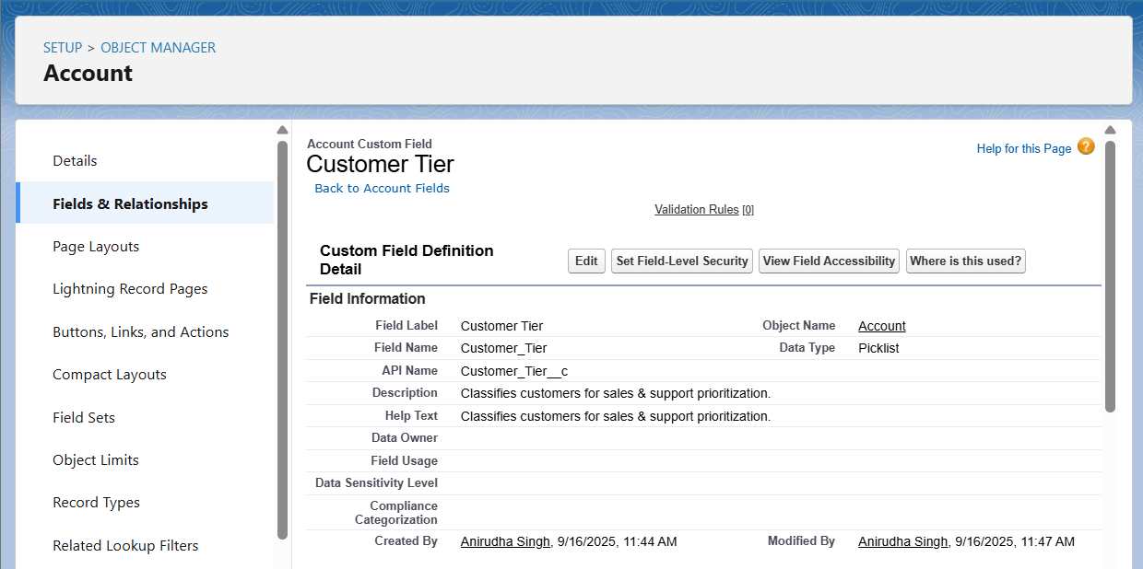

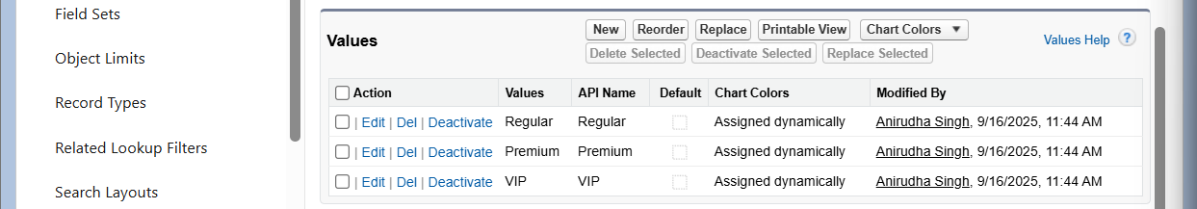

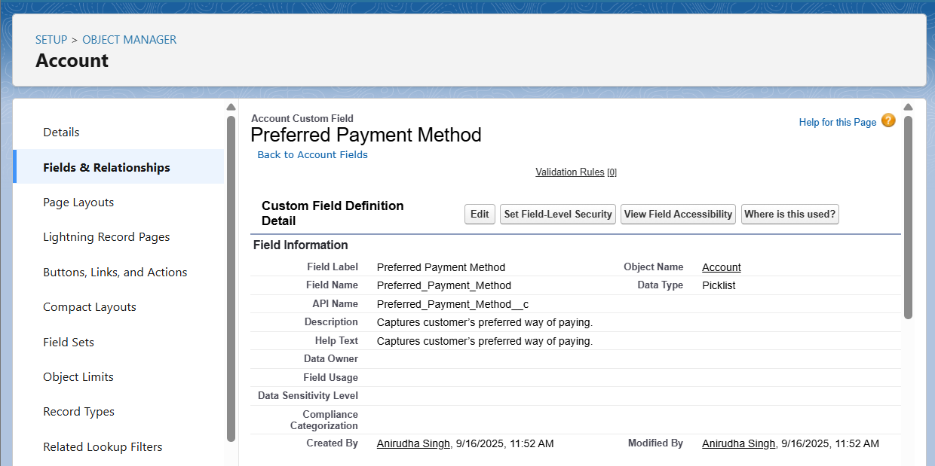  
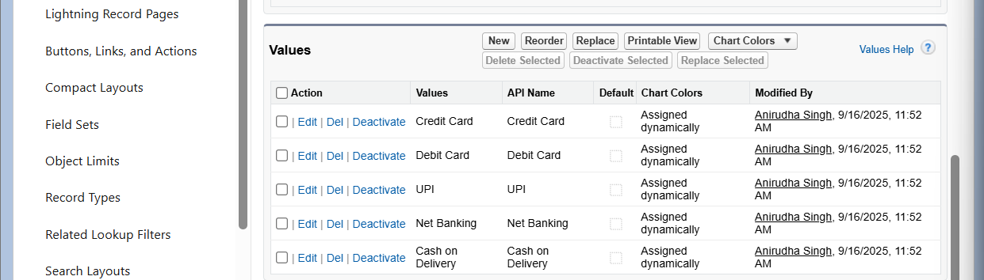  
Orders (Standard Object):  
- Payment Status (Picklist)  
- Delivery Method (Picklist)  
- PO Number (Text)

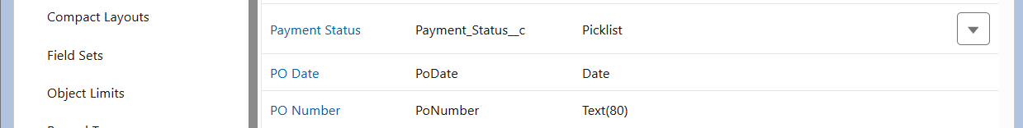

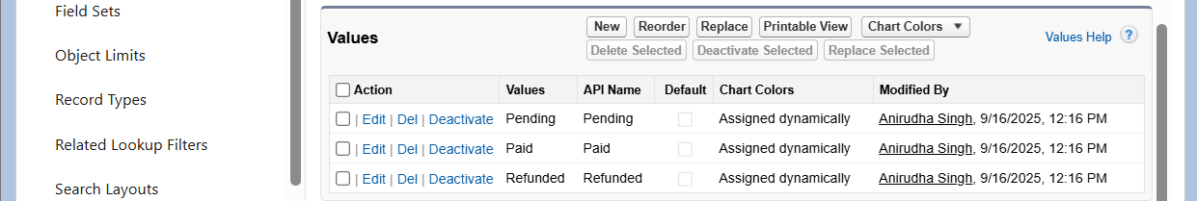



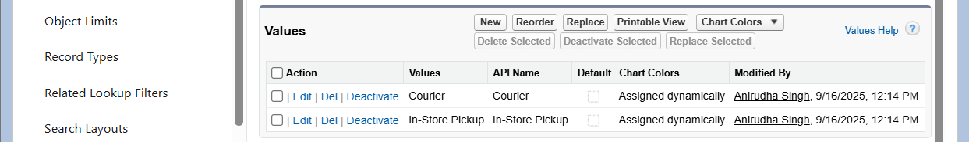  
  
Order Item (Order_Item__c):  
- Quantity (Number)  
- Unit Price (Currency)  
- Subtotal (Formula: Quantity × Unit Price)  
- Discount (%) (Percent)  
- Net Amount (Formula: Subtotal – Discount)

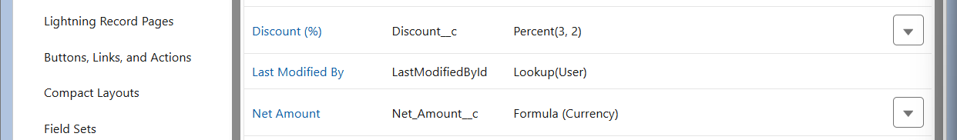

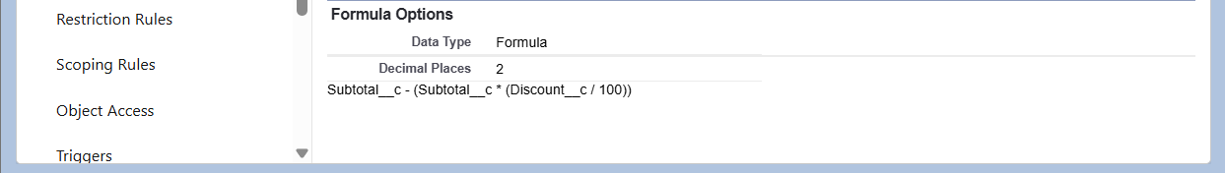

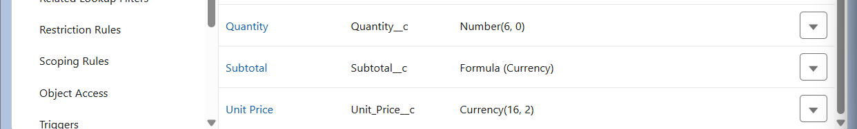  
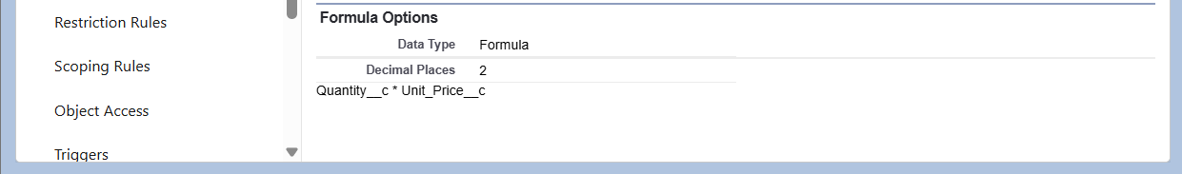  
Inventory (Inventory__c):  
- Product (Lookup → Product2)  
- Quantity On Hand (Number)  
- Reorder Level (Number)  
- Status (Picklist: Available, Reserved, Out of Stock)  
Validation Rule: Quantity On Hand cannot be negative.  
Field History Tracking: Enabled for Quantity On Hand and Status.

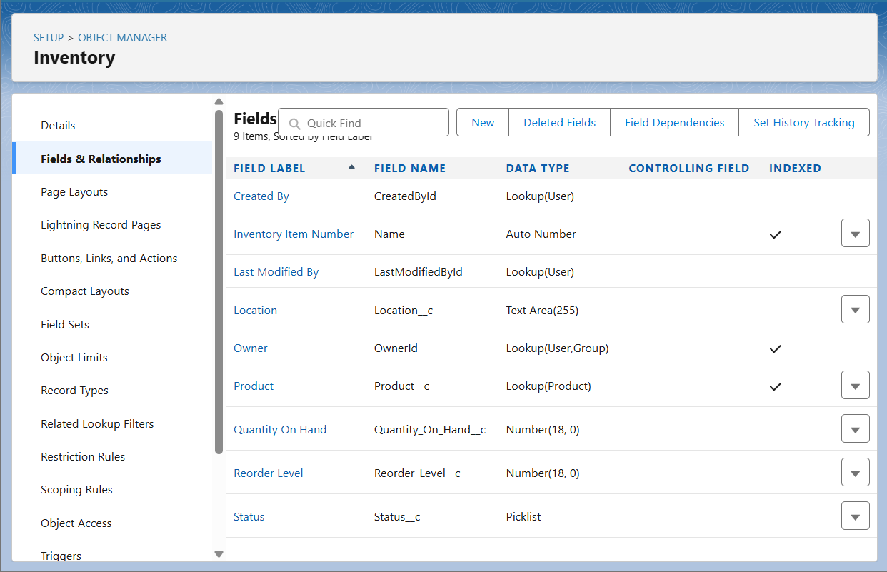  
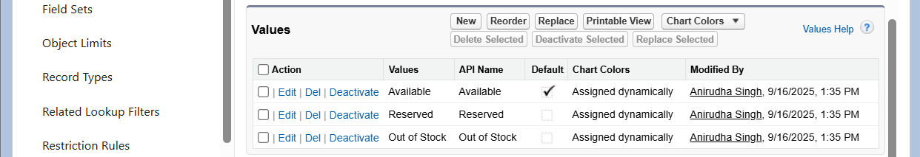

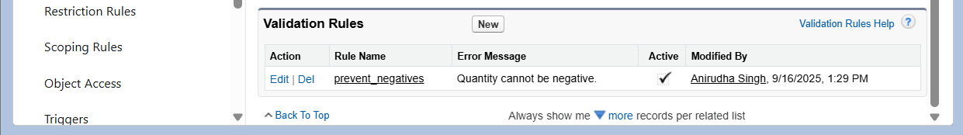  
Cases:  
- Issue Category (Picklist: Delivery, Payment, Product Quality, Other)  
- Resolution Time (Hrs) (Formula: ClosedDate – CreatedDate)



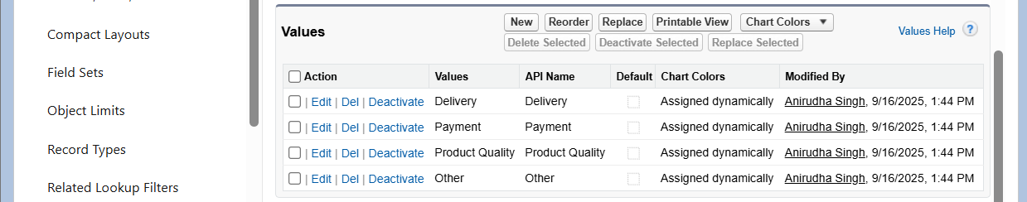



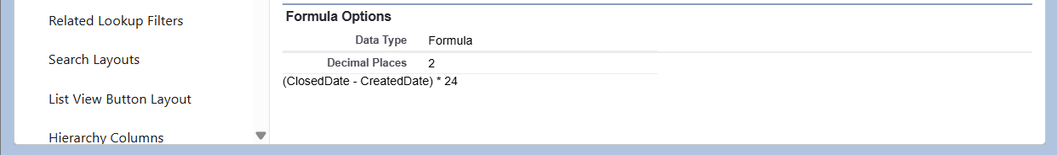

## Record Types

Accounts:  
- Customer (default for Sales Manager, Support)  
- Partner/Vendor (used for reseller/partner accounts)

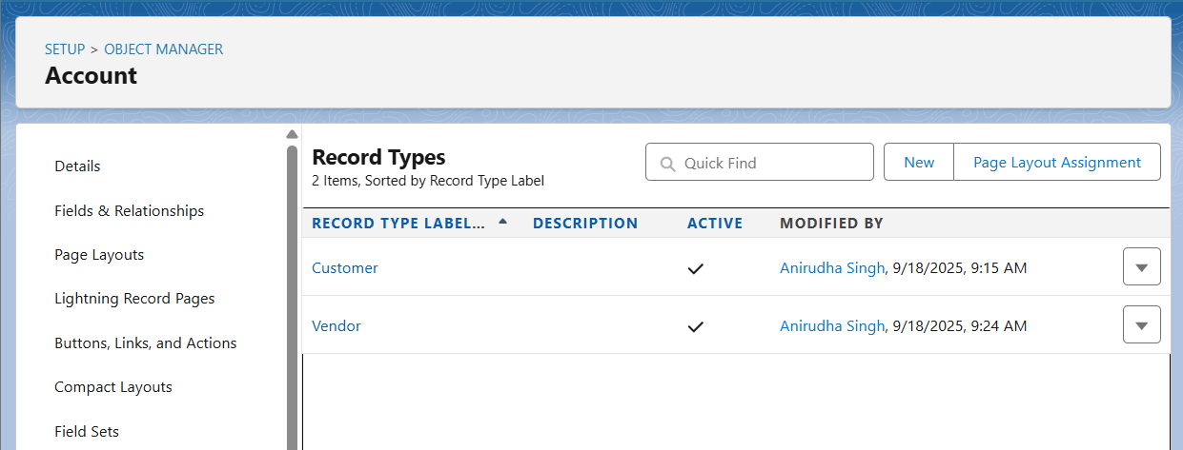  
Orders:  
- B2B Order: Includes PO Number and fields for business contracts.  
- B2C Order: Includes Payment Method and Delivery Slot (if added).

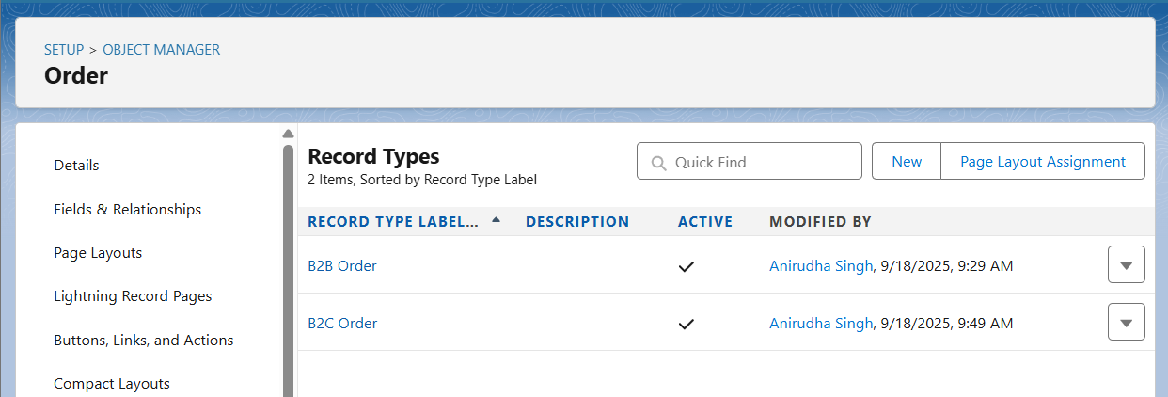  
Cases:  
- Complaint  
- Return  
- General Inquiry  
(Each linked to a Support Process to control Status values.)

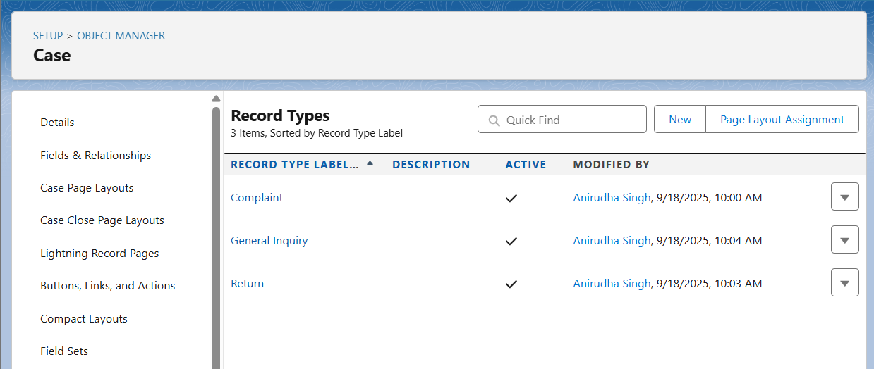

## Page Layouts

Accounts:  
- CEO Layout: Full financial details (Annual Revenue).  
- Sales Manager Layout: Customer-facing fields, hides financial codes.  
- Support Layout: Simplified view, focused on Cases.

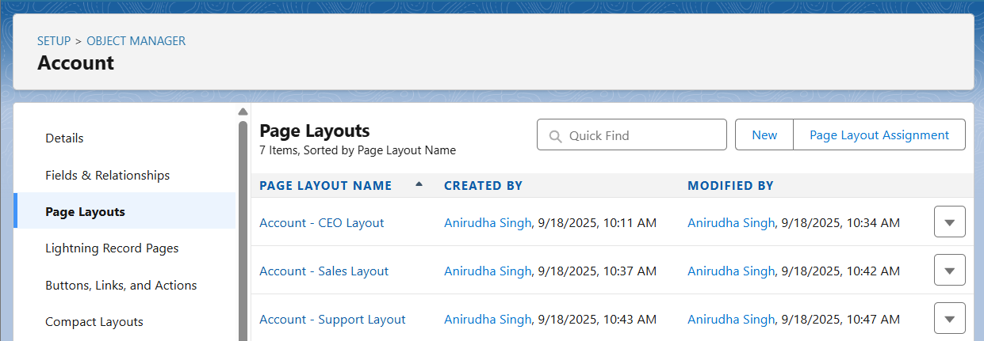  
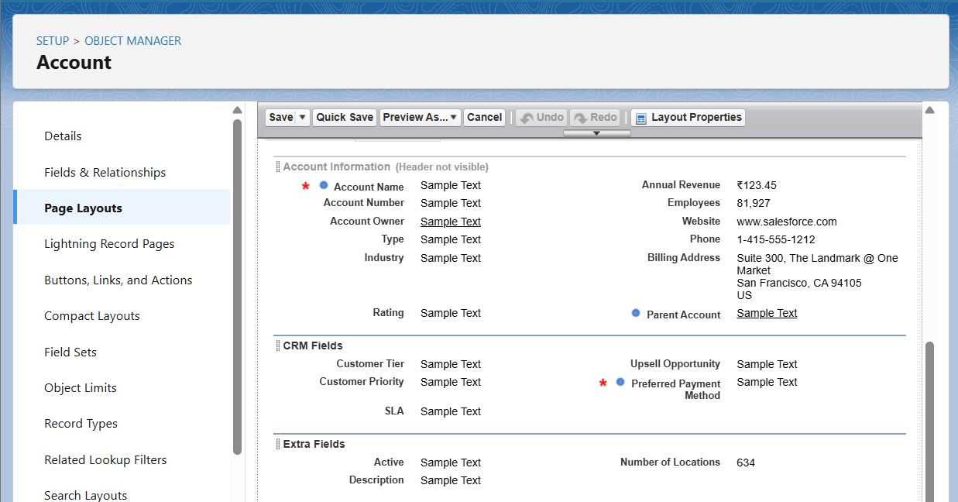

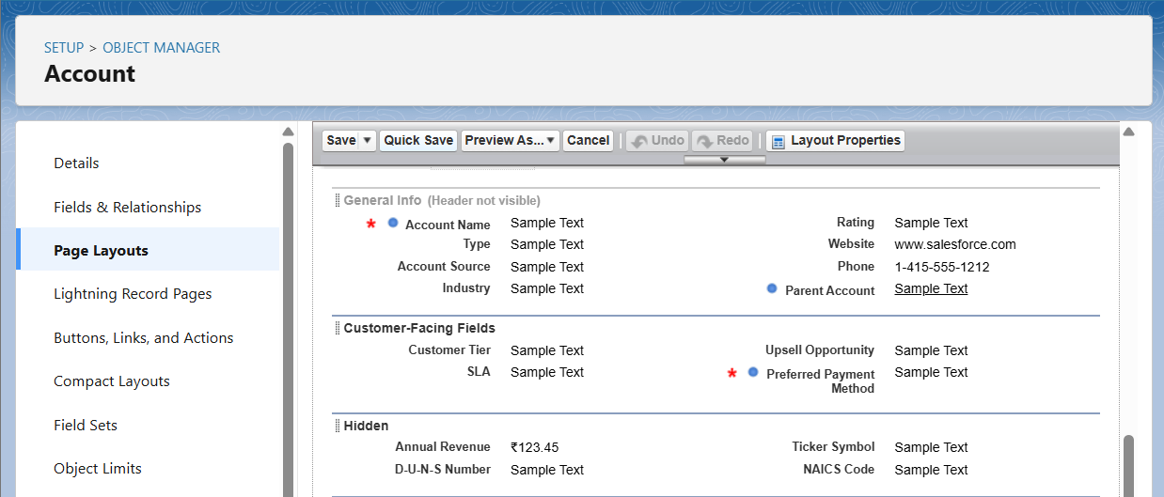

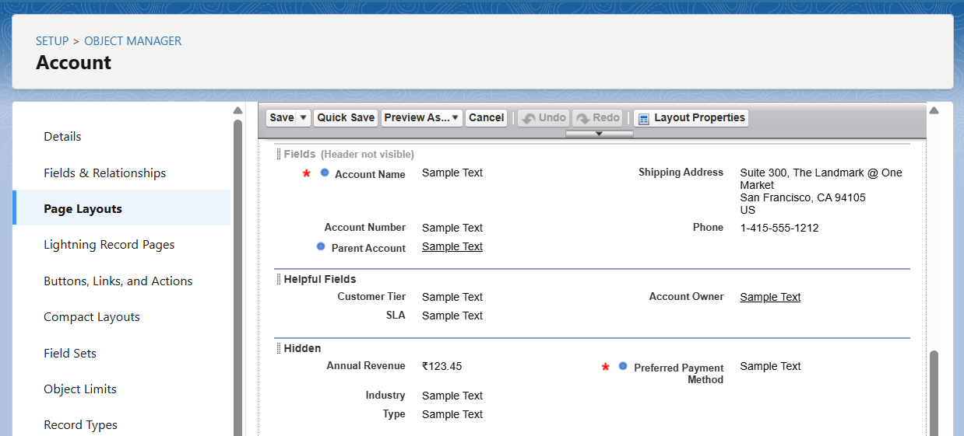  
Orders:  
- CEO Layout: All key fields (Order Amount, Payment Status, Dates).  
- Sales Manager Layout: Order details with B2B/B2C variations.  
- Warehouse Layout: Focused on shipping info and Order Items.  
- Support Layout: Order details tied to customer issues.

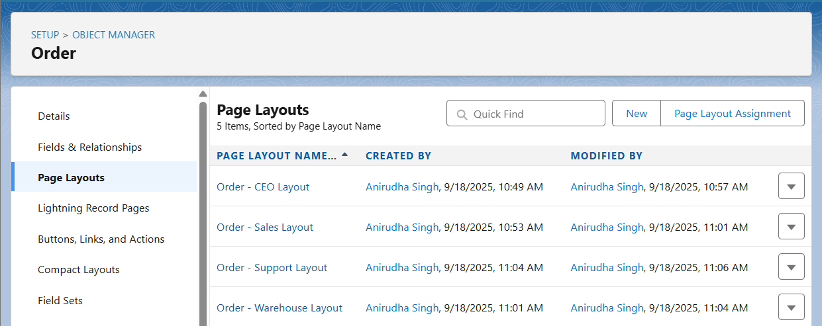  
Order Item:  
- Single layout showing Product, Quantity, Pricing details.

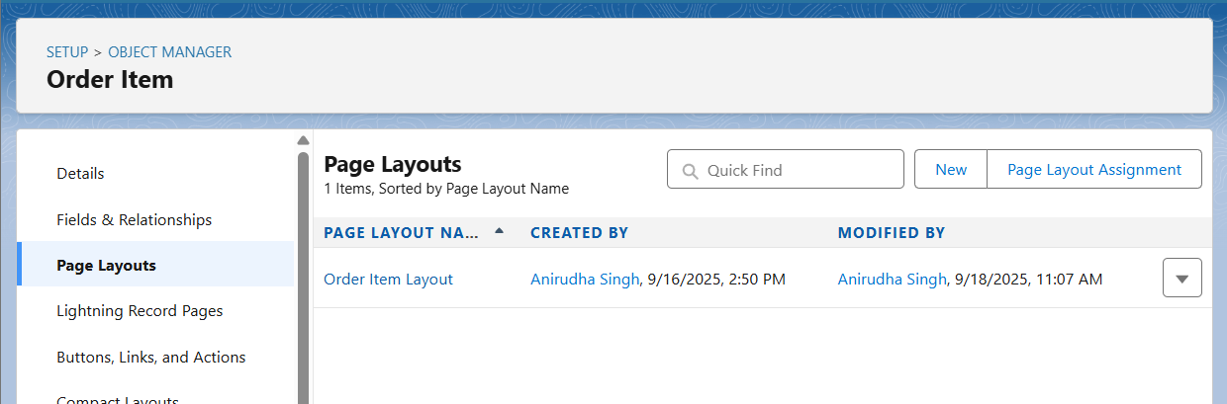  
Inventory:  
- CEO Layout: Stock status overview.  
- Warehouse Layout: Editable Quantity, Reorder Level, Status.

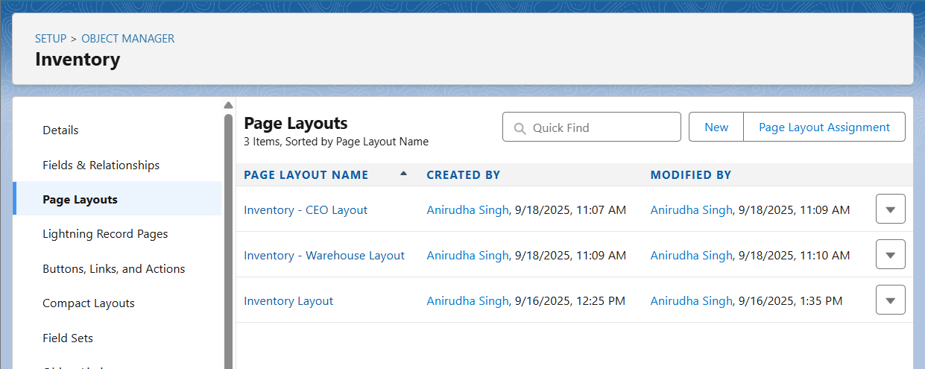  
Cases:  
- CEO Layout: Overview of customer issues.  
- Support Layout: Full detail including Issue Category, Resolution.

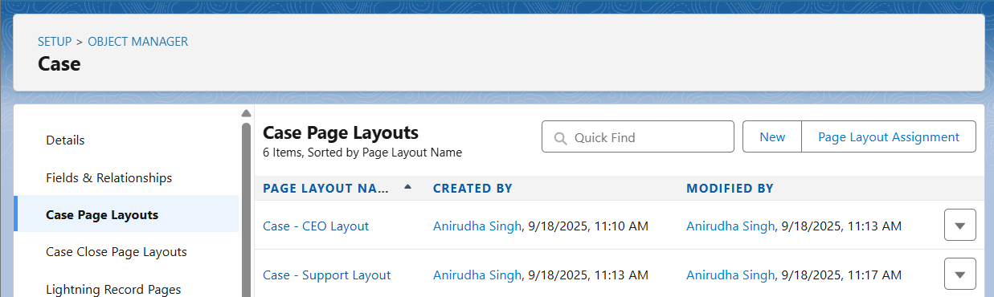

## Compact Layouts

Configured compact layouts for mobile/highlights panel:  
  
Orders: Order Number, Status, Payment Status, Order Amount, Effective Date, End Date.  
Inventory: Product, Quantity On Hand, Reorder Level, Status.  
Cases: Case Number, Subject, Status, Priority, Issue Category, Account, Contact.  
Accounts: Account Name, Type, Phone, Industry, Customer Tier, Preferred Payment Method.

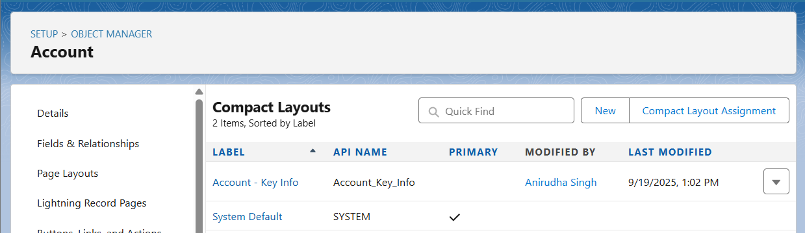

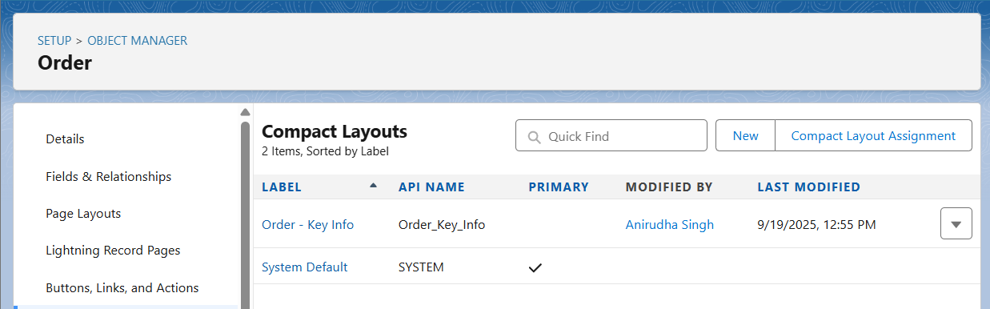

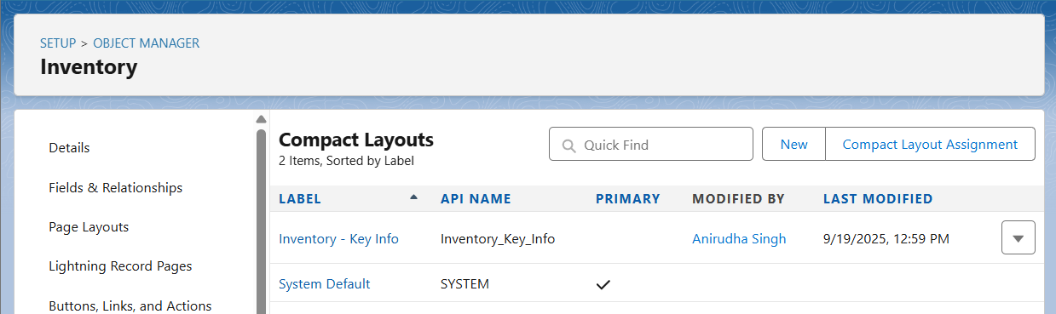

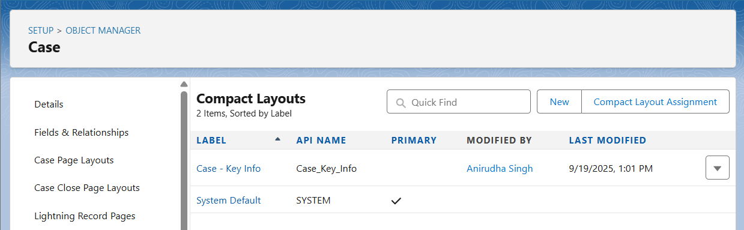

## Schema Builder

Objects included: Account, Contact, Order, Order Item, Product2, Inventory, Case.  
  
Verified relationships:  
- Account → Order  
- Order → Order Item  
- Order Item → Product2  
- Product2 → Inventory  
- Account → Case  
- Contact → Case  
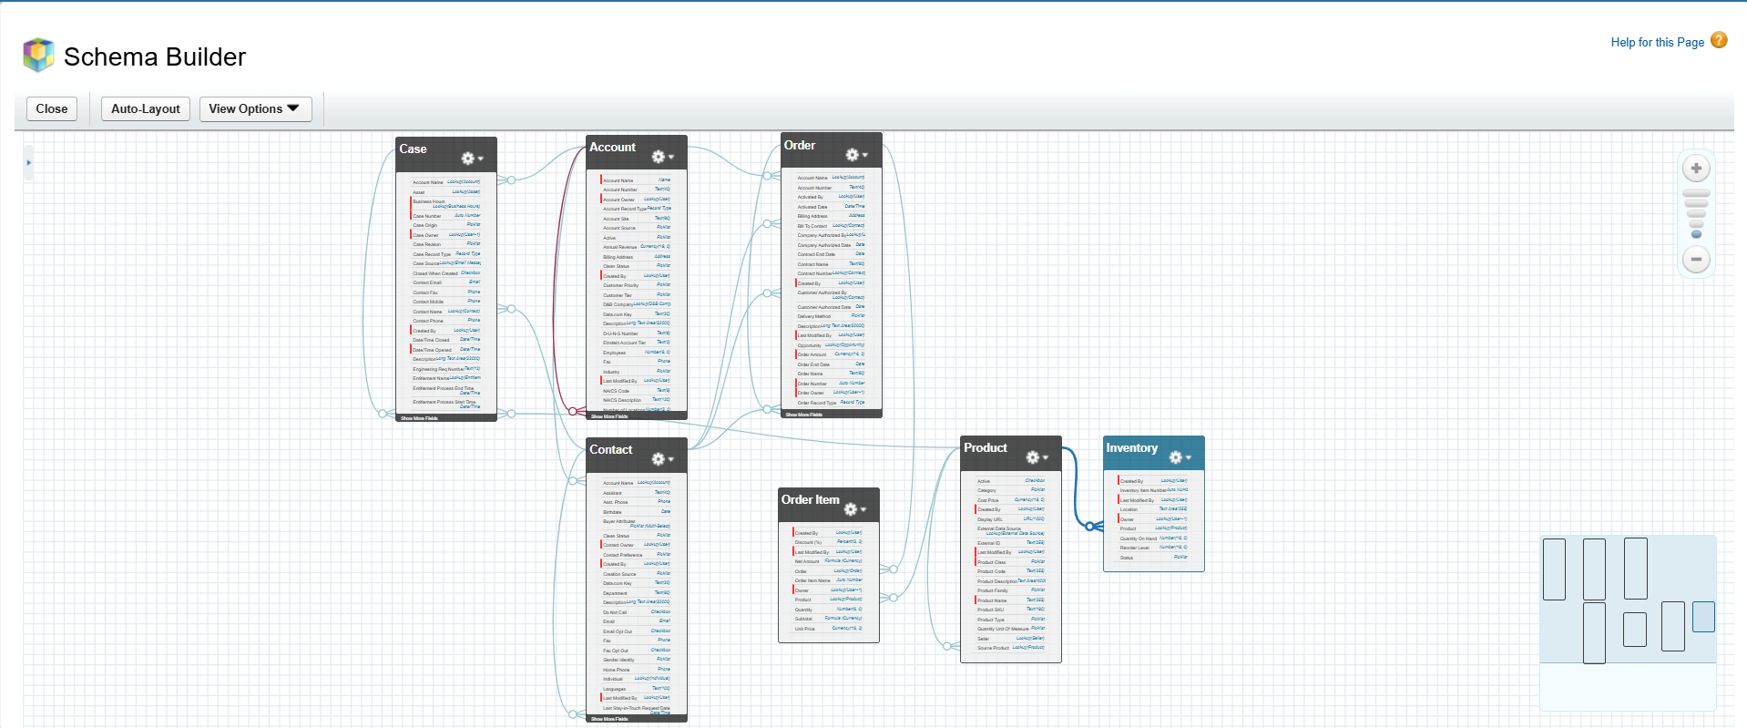

## Lookup vs Master-Detail vs Hierarchical Relationships

- Lookup Relationships: Used for linking objects without tight dependency (e.g., Inventory → Product2).  
- Master-Detail Relationships: Not implemented, since deletion or roll-up dependencies not required in this model.  
- Hierarchical Relationships: Only available on User object, not used in this project.

## Junction Objects

Order Item (Order_Item__c) is used as a junction object to manage many-to-many relationships:  
- One Order can contain many Products.  
- One Product can belong to many Orders.  
This is achieved by creating a junction between Order and Product2.

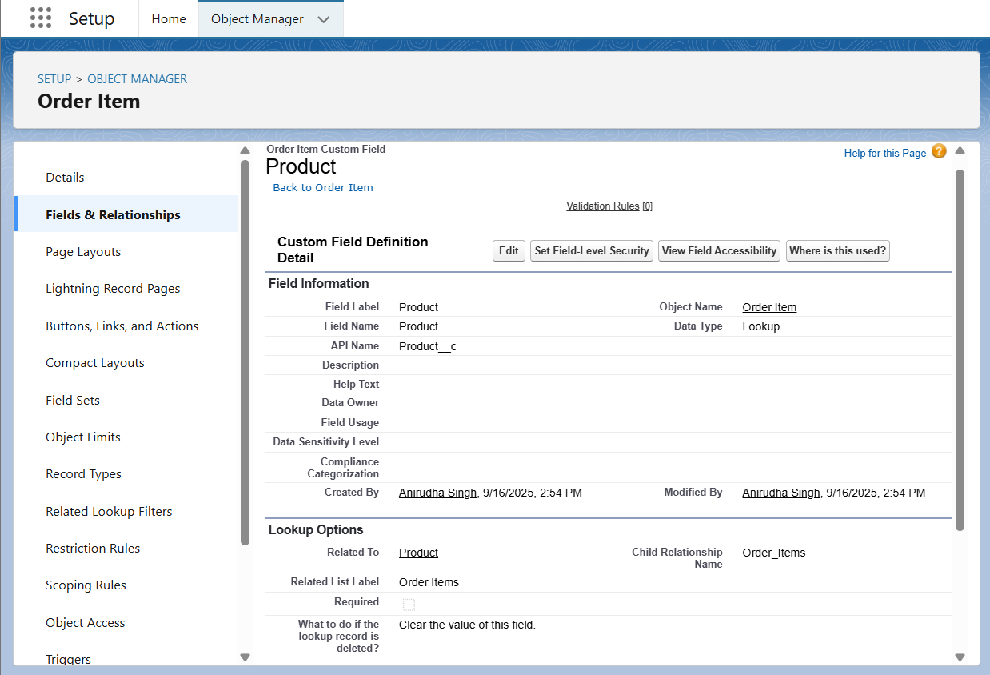

## External Objects

External Objects are not implemented in Developer Edition but documented for future integration.  
Example: ShopSmart may connect its Salesforce org with a Warehouse ERP system.  
- Tool: Salesforce Connect using OData adapter.  
- External Object Example: Warehouse_Stock__x.  
- Relationship: Warehouse_Stock__x could relate to Product2 to show real-time stock levels.  
This would extend visibility of inventory without duplicating data in Salesforce.